**Course7-Play the custom music Painters**

****Learning goals:****

In this lesson, you will learn how to play the music "The Painter."

**Code：**

from microbit import *

import music

display.show(Image.MUSIC_QUAVER)

tune = ["G4:2", "E4:2", "G4:2", "E4:2", "G4:2", "E4:2", "C4:4", "D4:2", "F4:2",

"E4:2", "D4:2", "G4:4", "E1:4", "G4:2", "E4:2", "G4:2", "E4:2", "G4:2",

"E4:2", "C4:4", "D4:2", "F4:2", "E4:2", "D4:2", "C4:4", "E1:4", "D4:2",

"D4:2", "F4:2", "F4:2", "E4:2", "C4:2", "G4:4", "D4:2", "F4:2", "E4:2",

"D4:2", "G4:4", "E1:4", "G4:2", "E4:2", "G4:2", "E4:2", "G4:2", "E4:2",

"C4:4", "D4:2", "F4:2", "E4:2", "D4:2", "C4:4"]

music.play(tune)

**Programming and downloading：**

1. You should open the Mu software, and enter the code in the edit window, , as shown in Figure 7-1.

**Note! All English and symbols should be entered in English, and the last line must be a space.**

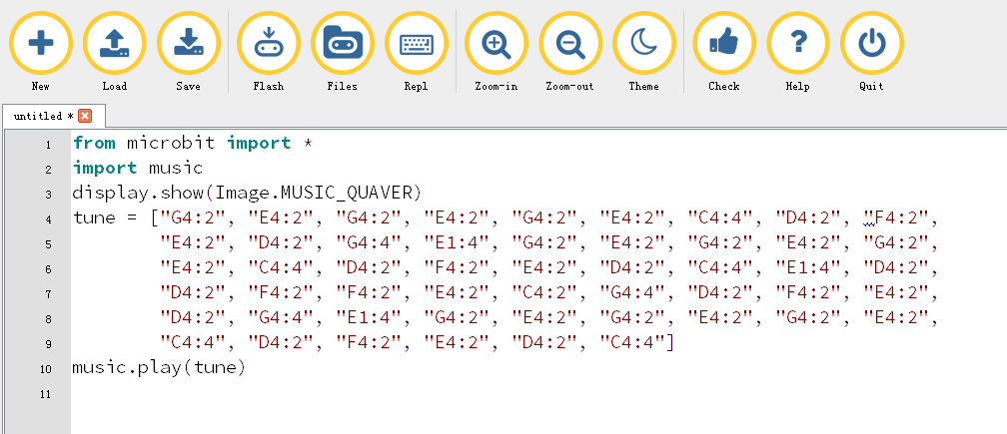

Figure 7-1

2. As shown in Figure 7-2, you need to click the Check button to check if our code has an error. If a line appears with a cursor or an underscore, the program indicating this line is wrong.

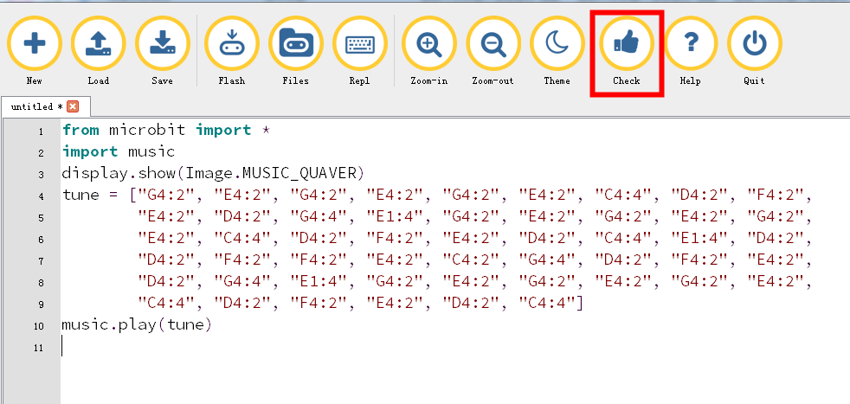

Figure 7-2

3.You need to connect the micro data cable to micro:bit and the computer, then click the Flash button to download the program to micro:bit as shown in Figure 7-3.

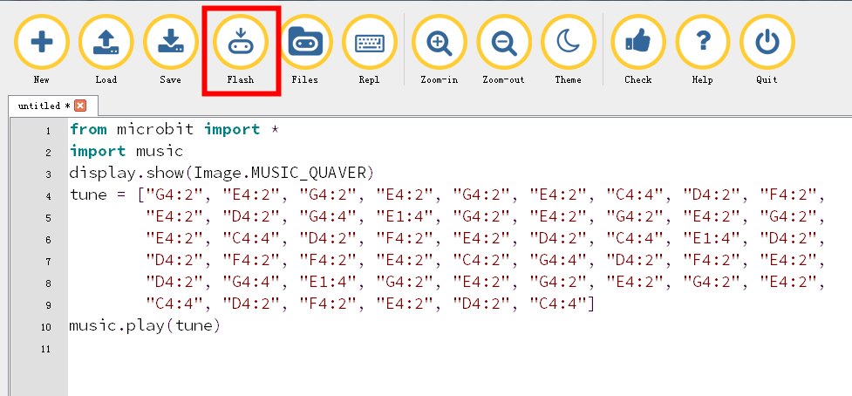

Figure 7-3

4.After downloading the program to micro:bit, you can hear t the music "Painter", and there is a note on the dot matrix as shown in Figure 7-4.

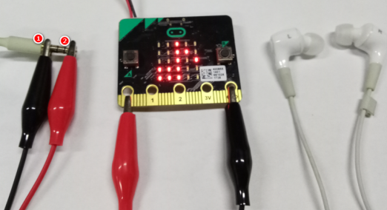

Figure7-4